CS 255 System Design Document

Jeremy Pauley, 10/17/2026

Table of Contents
CS 255 System Design Document 1
Jeremy Pauley, 10/15/2026 1
UML Diagrams 2
UML Use Case Diagram 2
UML Activity Diagrams 3
UML Sequence Diagram 5
UML Class Diagram 6
Technical Requirements 7
Technical Design Approach 7
Hardware Requirements 8
Software Requirements 9
Customer Registration and Account Management 11
Training Packages and Customer Eligibility 12
Driving Lessons and Scheduling 13
Customer Communication and Reporting 14
Development Tools 15
Infrastructure Requirements 16
Security Requirements 17
Design Assumptions and Open Decisions 19

UML Diagrams

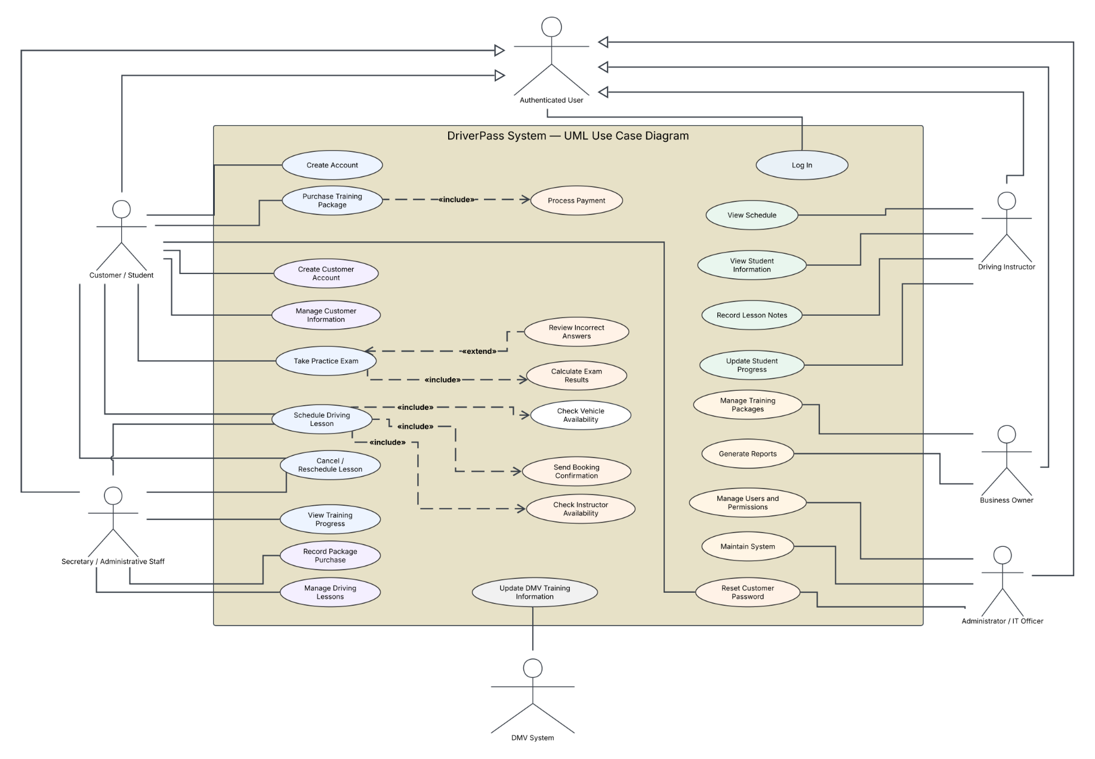
UML Use Case Diagram

The use case diagram identifies the customer/student, secretary/admin, instructor, owner, administrator/IT officer, and external DMV system that interact with DriverPass. It separates business management responsibilities from technical administration while showing customer training, payment, scheduling, and reporting functions.

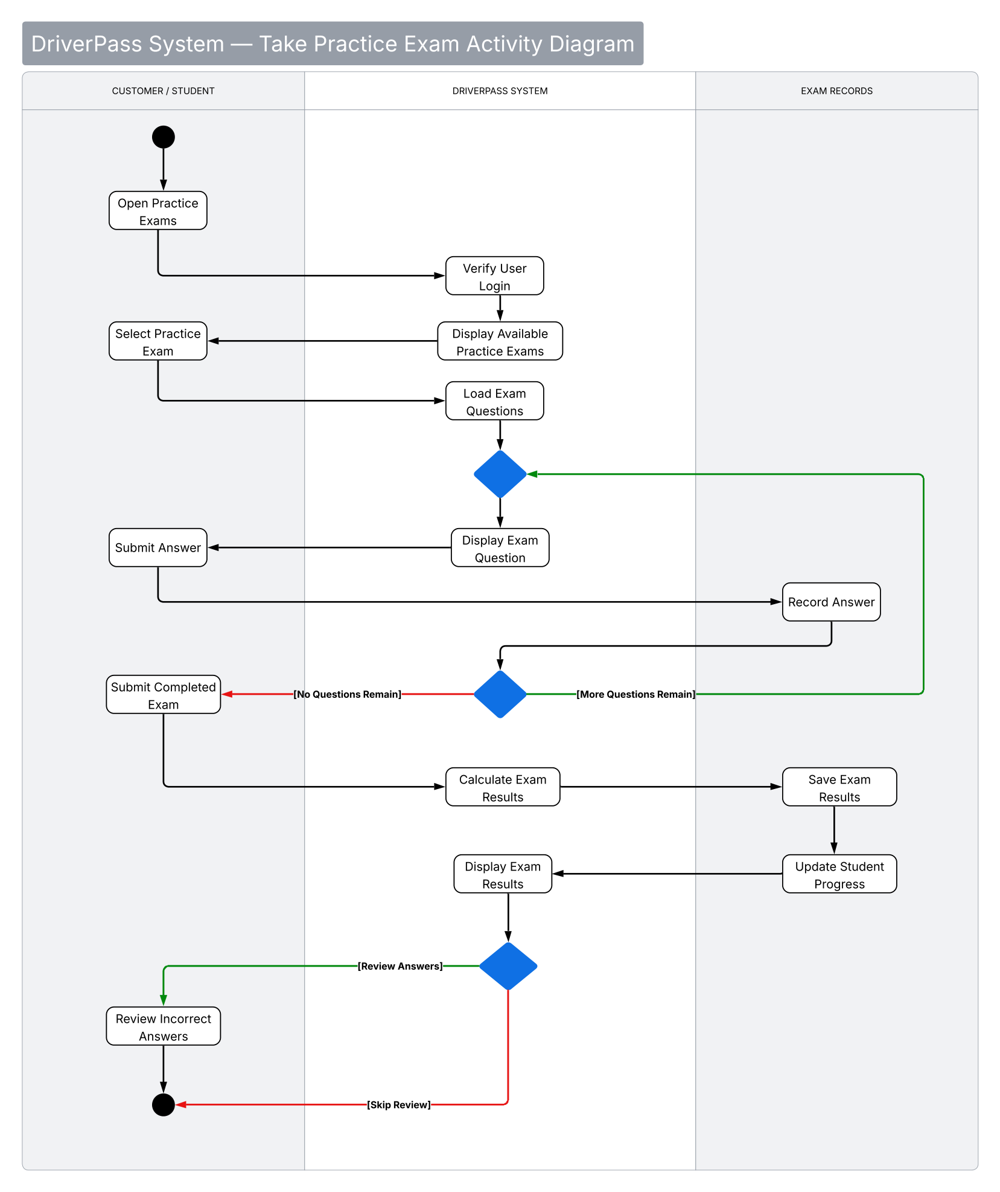
UML Activity Diagrams
This activity model follows the customer/student through authentication, exam selection, question completion, score calculation, and progress recording. It includes the option to review incorrect answers after results are displayed.
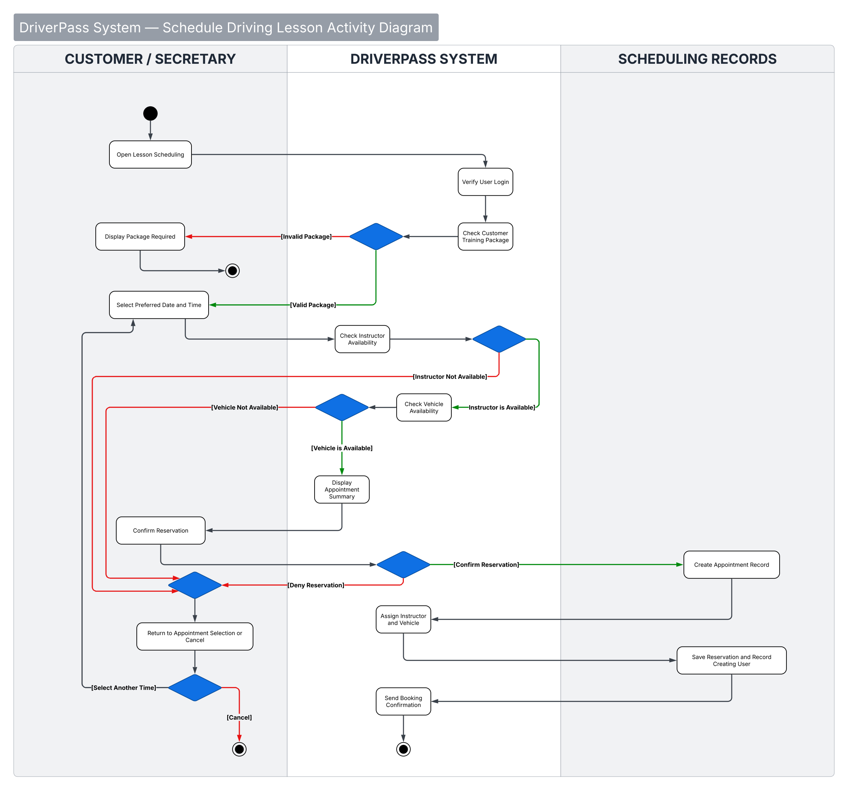
This activity model shows package eligibility and instructor/vehicle availability checks before a two hour appointment is confirmed. It includes alternative outcomes for unavailable resources, retrying, and canceling.

UML Sequence Diagram
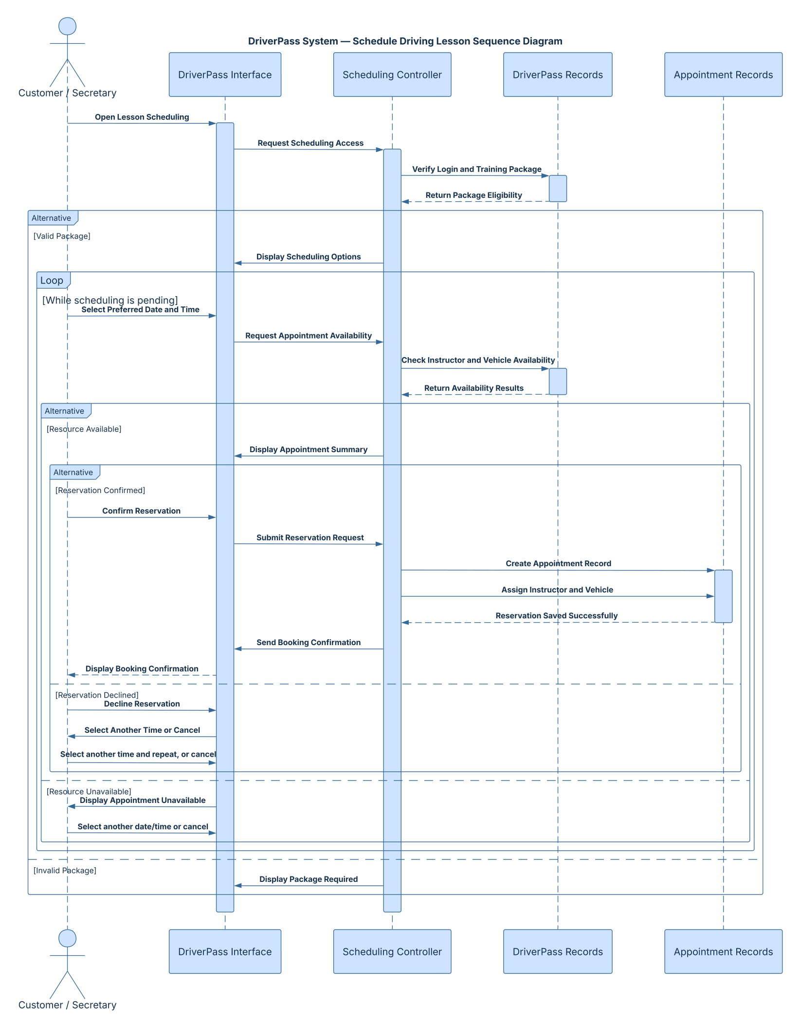
The sequence diagram details communication between the user, DriverPass interface, scheduling controller, and stored records. It demonstrates the order of validation, availability checks, appointment creation, and confirmation, including unsuccessful booking paths.

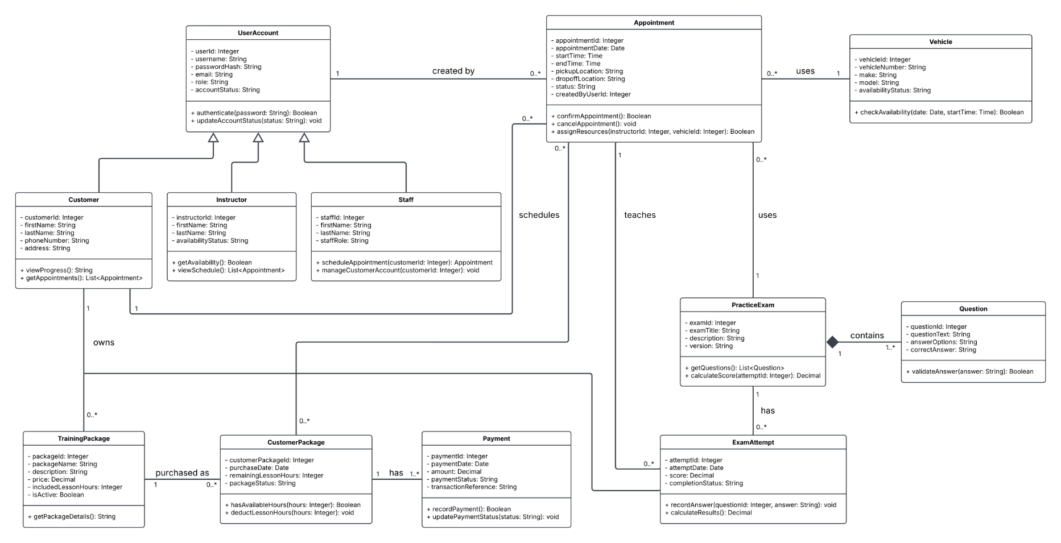
UML Class Diagram

The class diagram models the core entities and their relationships, including user accounts, customers, instructors, staff, appointments, vehicles, training packages, practice examinations, attempts, questions, and payments. Associations and multiplicities describe how records relate to one another.

Technical Requirements

Technical Design Approach
The DriverPass system is designed to bring customer training, practice examinations, driving lesson scheduling, and business administration together into one dependable platform. While each of these services serves a different purpose, they rely on much of the same information. A centralized system allows DriverPass to manage those relationships without requiring employees to maintain separate records or users to navigate multiple applications.

The proposed design uses a web application supported by Microsoft Azure. Customers and employees will access the same system through a supported browser, eliminating the need for specialized application installations. This approach also allows DriverPass to maintain its information in one location while supporting access from computers, tablets, and smartphones.

The application will use the following technical foundation:

- React with TypeScript: Provides the interface customers and employees use to interact with DriverPass.
- Node.js with TypeScript: Manages application operations, including scheduling, customer eligibility, authentication, and payment coordination.
- Microsoft Azure: Provides the hosting environment, database services, storage, monitoring, and recovery infrastructure.
- Azure SQL Database: Maintains the relationships between customer accounts, training packages, appointments, instructors, vehicles, and business records.
- Stripe: Processes customer payments through a secure hosted checkout service.

Using TypeScript for both the user interface and the backend application services provides consistency across development and reduces the number of programming languages the team must maintain. The Node.js application services will also provide a central location for enforcing business rules, ensuring those rules remain consistent regardless of how a customer or employee accesses the system.

The proposed Microsoft environment assumes DriverPass already uses Microsoft 365 and has an established Microsoft Entra tenant. This assumption requires confirmation before implementation. Azure resources must also be provisioned and approved separately because their costs are not automatically included with Microsoft 365.

Hardware Requirements
A browser based system reduces the need for specialized equipment because most customer and employee activities can be completed using standard devices. The primary hardware requirement is a device capable of running a supported modern browser and maintaining a reliable internet connection.
The following equipment will support DriverPass operations:
- Customer Devices: Computers, tablets, or smartphones with internet access and a supported browser for training materials, practice examinations, and appointment management.
- Administrative Workstations: Standard office computers for customer registration, scheduling, reporting, and business administration.
- Instructor Devices: Supported computers, tablets, or smartphones for reviewing assigned lessons and recording instruction details.
- Cloud Infrastructure: Microsoft Azure resources for application processing, database operations, and file storage rather than physical servers maintained at the DriverPass office.
This arrangement allows DriverPass to focus its equipment purchases on the needs of employees rather than maintaining dedicated application servers.
The final amount of computing capacity will depend on expected customer activity, the number of simultaneous users, anticipated data storage, and performance requirements. These values must be established during implementation planning so DriverPass does not purchase more infrastructure than necessary.

Software Requirements
The software design separates the interface users interact with from the application services responsible for processing information and enforcing business rules. This separation allows the system to provide different experiences for customers and employees while maintaining consistent behavior behind the scenes.
The proposed software components include:
- React with TypeScript: Provides reusable interface components for registration, scheduling, training access, practice examinations, and employee administration.
- Node.js with TypeScript: Processes user accounts, purchases, appointments, practice examinations, and employee operations through secure application interfaces.
- Azure SQL Database: Stores customer information, training packages, lesson records, vehicles, instructors, examination results, payment references, and activity history.
- Stripe Checkout: Collects and processes payment information without requiring DriverPass to store complete payment card details.
- Microsoft Entra Services: Support authentication and account management for employees and customers through appropriate identity services.

The application must also support responsive layouts and be tested across supported browsers and screen sizes. Using TypeScript does not automatically make an interface accessible or responsive, so those requirements must be addressed through interface design and testing.
Several operational rules will be enforced by the application services:
- Confirm that customers have the necessary training hours before allowing them to schedule lessons.
- Enforce the required two hour duration for driving lessons.
- Prevent instructors or vehicles from being assigned to overlapping appointments.
- Verify availability again when an appointment is saved to prevent conflicting reservations.
- Record the person responsible for creating, modifying, or canceling appointments.
- Maintain customer training eligibility and practice examination history.
- Verify payment notifications before granting access to purchased services.
These rules are especially important because customers and administrative employees may perform the same operations through different interfaces. Centralizing the rules ensures the outcome remains consistent regardless of who initiates the request.
Azure SQL Database is recommended because the information maintained by DriverPass is closely connected. Customers purchase training packages, packages determine eligibility, appointments connect customers with instructors and vehicles, and practice examinations produce results associated with individual accounts.
Practice examination records must preserve the examination name, elapsed time, score, and current status. Supported statuses include not taken, in progress, failed, and passed.
Stripe will manage payment collection through its hosted checkout service. Once payment is completed, the application must verify the notification received from Stripe before updating the customer's purchased services. Previously processed notifications must also be recognized to prevent duplicate fulfillment.
Although Stripe supports recurring subscriptions, subscription billing is not included in the initial DriverPass requirements.
The application must also support updates to DMV rules, policies, and sample questions, with notifications provided to authorized employees when new information becomes available. The exact method for receiving these updates remains undetermined because the available DMV integration options have not yet been confirmed.

Customer Registration and Account Management
Customer registration establishes the information DriverPass needs to manage training services, schedule lessons, and communicate with customers. The process should be straightforward while still validating the information required for business operations.
The registration process must collect:
- Customer first and last name.
- Residential address and state.
- Contact phone number.
- Required pickup and dropoff locations.
- Account information necessary for secure authentication.
The application must verify that the customer's pickup and dropoff locations match, as required by DriverPass procedures.
Customers will be able to create and maintain their accounts online. Authorized administrative employees must also be able to register customers and update the customers information when assisting someone by telephone or in person.
Payment information will be collected through Stripe's hosted checkout rather than stored directly within the DriverPass database.
Providing both customer access and administrative assistance allows DriverPass to support customers who prefer managing their own accounts while maintaining the personal service available through its office.

Training Packages and Customer Eligibility
DriverPass currently offers three training packages, each providing a different combination of driving instruction and educational resources. The system must maintain these differences because a customer's purchased package determines which services are available.
- Package One: Six hours of driving instruction, completed through three sessions of two hours each.
- Package Two: Eight hours of driving instruction, along with an in person lesson covering DMV rules and policies.
- Package Three: Twelve hours of driving instruction, an in person lesson covering DMV rules and policies, and access to online training materials and practice examinations.
The system must track the services and driving hours associated with each purchased package.
Required capabilities include:
- Record the package purchased by each customer.
- Track the total driving instruction hours included in the package.
- Record completed instruction hours and calculate remaining eligibility.
- Restrict access to online courses and practice examinations according to the purchased package.
- Prevent additional lesson reservations when the customer has insufficient remaining training hours.
- Allow authorized employees to disable packages for new purchases.
- Preserve the purchased services of existing customers when a package is disabled.
Preserving previously purchased services is important because removing a package from sale should not remove benefits customers have already paid for.
The initial design will support the three established packages. Adding or removing system modules is outside the current scope and may be considered during a future expansion, however the design is easy to scale with additional packages.

Driving Lessons and Scheduling
Driving lesson scheduling requires coordination between customers, instructors, vehicles, and available training hours. Because these resources are shared, the system must validate availability before confirming an appointment.
Customers must be able to schedule, modify, and cancel appointments through their online accounts. Authorized administrative employees must be able to perform the same actions on behalf of customers who contact DriverPass by telephone or visit the office.
Each reservation must maintain:
- Customer information.
- Assigned driving instructor.
- Assigned vehicle.
- Appointment date and time.
- Required two hour lesson duration.
- Reservation status and relevant activity history.
Before confirming a reservation, the application must verify that the customer has sufficient training hours and that the instructor and vehicle are available.
Availability must be checked again when the reservation is saved. This prevents conflicting appointments when multiple users attempt to reserve the same resources at approximately the same time.
When appointments are modified or canceled, the system must update the associated scheduling information so the affected instructor and vehicle availability remains accurate.
Following a completed lesson, the assigned instructor must be able to record:
- Actual lesson start time.
- Actual lesson end time.
- Comments regarding the instruction provided.
Maintaining these records allows DriverPass to monitor customer progress, verify completed training, and maintain an accurate history of instruction.

Customer Communication and Reporting
Communication and reporting are important because DriverPass must support both customer service and internal accountability. A centralized application should make information easier to access while maintaining clear records of important business activities.
The system must provide:
- Customer Communication: A method for customers to contact DriverPass through the application.
- Employee Communication: A method for authorized employees to contact customers regarding appointments and training services.
- Operational Reporting: The ability for authorized users to generate, view, print, and download business reports.
- Reservation Activity Reporting: Records identifying who created, modified, or canceled appointments and when those actions occurred.
- Offline Report Access: Downloadable reports that can be reviewed using applications such as Microsoft Excel.
Reservation activity records are particularly valuable when a scheduling discrepancy occurs. Rather than relying on employee recollection, authorized personnel can review the history of an appointment to understand what changed and who performed the action.
Downloaded reports may be reviewed offline. However, modifications to live customer records, appointments, and other centralized information will require an active internet connection.
This distinction helps maintain one authoritative set of business records and reduces the risk of conflicting information.

Development Tools
Development tools should support collaboration, testing, maintenance, and reliable deployment without introducing unnecessary complexity. The proposed toolset focuses on technologies that work well with the selected application architecture.
Recommended tools include:
- Visual Studio Code: Primary development environment for React, Node.js, and TypeScript.
- Visual Studio: An optional development environment when specific tasks benefit from its additional capabilities.
- Git: Version control for tracking changes, reviewing previous work, and coordinating development.
- Azure DevOps: A proposed platform for automated builds, testing, and deployment, subject to licensing and team preferences.
- Lucidchart: Modeling software used to document the application's structure and behavior through UML diagrams.
- Database Development Tools: Utilities for creating, maintaining, and validating database structures and queries.
- Automated Testing Tools: Support testing of application interfaces, business rules, and system integrations.
- Browser and Accessibility Testing Tools: Verify usability and accessibility across supported devices and browsers.
The development team should select tools based on their contribution to the project rather than adopting additional software simply because it belongs to the Microsoft ecosystem.
A consistent development environment will make the application easier to maintain and help future developers understand how the system was built.

Infrastructure Requirements
Microsoft Azure is recommended as the hosting environment because it provides managed services for application hosting, databases, storage, monitoring, and recovery.
Using managed cloud services reduces the need for DriverPass to purchase and maintain physical servers while providing a centralized environment for the application.
The proposed infrastructure includes:
- Azure App Service: Hosts the Node.js application services and may support the frontend deployment, depending on the final hosting arrangement.
- Azure SQL Database: Maintains structured application and business records.
- Azure Blob Storage: May store training documents, course resources, and downloadable materials.
- Azure Monitor and Application Insights: Provide operational monitoring and information needed to investigate performance or application problems.
- Microsoft Entra Services: Support employee and customer authentication through the appropriate identity services.
- Stripe Integration: Provides payment processing through an external payment service.
- DMV Information Integration: Supports approved updates to training rules, policies, and practice questions.
The infrastructure must also provide:
- Secure HTTPS connections.
- Controlled access to application data and administrative functions.
- Automated backups and documented recovery procedures.
- Monitoring of application availability and operational problems.
- Reliable internet connectivity for live application activity.
Customers will not need Microsoft 365 subscriptions to access DriverPass. Customer authentication will be handled through an appropriate identity service.
Reports downloaded from the application may be reviewed offline, but changes to those reports will not automatically update the central database.
Before infrastructure resources are purchased or provisioned, the proposed capacity and ongoing service costs must be reviewed against DriverPass's approved budget. The final frontend hosting arrangement will also be determined during implementation planning.

Security Requirements
Security is an important part of the DriverPass design because the system will maintain customer information, training records, appointments, payment transactions, and administrative functions.
The proposed security approach focuses on three objectives, protecting information, limiting access according to responsibilities, and maintaining accountability for important actions.
Authentication and Account Management:
Every customer and employee must have an individual account so the system can identify the person accessing information or performing an action.
The following authentication controls are recommended:
- Employee Authentication: Microsoft Entra ID will provide centralized employee authentication, assuming DriverPass has the appropriate Microsoft environment.
- Customer Authentication: Microsoft Entra External ID or an equivalent service will provide secure customer access without requiring Microsoft 365 subscriptions.
- Account Recovery: Customers will be able to recover forgotten passwords, while the IT officer will have permission to reset or disable accounts.
- Login Protection: Repeated unsuccessful login attempts will trigger temporary restrictions. Multifactor authentication is recommended for administrative accounts.
- Multifactor Authentication: Additional authentication is recommended for accounts with elevated administrative privileges.
Account permissions must be manageable without requiring changes to the application's source code.
Access Control
The application will use role based access controls to ensure users can perform the activities associated with their responsibilities.
- Customers: Access to their own accounts, training materials, practice exams, and appointments.
- Secretaries: Access to customer administration and appointment management.
- Instructors: Access to assigned lessons and the ability to record training information.
- Business Owner: Access to authorized business records and operational reports.
- IT Officer: Access to account management, permissions, and technical administration.
These responsibilities must remain separate. For example, access to business reports does not automatically require permission to change account security settings.
The Node.js application services must verify a user's identity and permissions before completing protected operations.
Restricting what appears on a user's screen is helpful for usability, but it is not sufficient security by itself. The application must enforce access restrictions when processing each protected request.

Data Protection and Accountability
The system must protect information both while it is being transmitted and while it is stored.
Required controls include:
- Encrypted Communication: Information exchanged between user devices and DriverPass must use secure connections.
- Protected Storage: Sensitive information stored in Azure must be protected through appropriate encryption and access restrictions.
- Secure Credential Management: Application credentials and other sensitive configuration information must be maintained securely.
- Payment Security: Stripe will process payment card information through hosted checkout. DriverPass will retain only the transaction references and payment details needed for business operations.
- Payment Verification: The application must verify Stripe notifications before updating purchases or customer eligibility.
- Activity Monitoring: The system must maintain records of important account and reservation activities.
- Backup and Recovery: Azure infrastructure will support automated backups, monitoring, and documented recovery procedures.
Reservation activity records must identify the responsible user, affected appointment, action performed, and date and time of the change.
When appropriate, the history should also preserve previous and updated values so authorized personnel can understand what changed.
Authorized employees must be able to review, print, and download reservation activity reports when investigating discrepancies.
Together, these controls provide DriverPass with a system that protects customer information while maintaining clear responsibility for administrative actions.

Design Assumptions and Open Decisions
The proposed design establishes a technical direction for DriverPass, but several decisions require confirmation before implementation begins.
These items should be resolved during project planning to ensure the selected services, operating costs, and system capabilities match the organization's needs.
- Existing Microsoft Environment: Confirm whether DriverPass currently uses Microsoft 365 and maintains an established Microsoft Entra tenant.
- Azure Subscription and Licensing: Determine which Azure services must be provisioned and what licensing or subscription costs will apply.
- Approved Budget: Establish the budget available for implementation and ongoing operation.
- Expected Usage: Confirm anticipated customer volume, employee access, simultaneous users, and data storage requirements.
- Browser Support: Establish which browsers and device types must be officially supported.
- DMV Information Updates: Determine whether the DMV provides an approved API, downloadable information, or another supported method for distributing updates.
- Frontend Hosting: Finalize the hosting arrangement for the React interface.
- Backend Technology: Node.js with TypeScript is the selected implementation approach, rather than a technology specifically required by DriverPass.
- Future Reporting: Advanced Power BI reporting is not included in the initial design.
- Recurring Payments: Stripe subscription billing is not included unless DriverPass approves it as a future requirement.
Resolving these decisions before implementation will reduce uncertainty and help ensure the completed system meets DriverPass's operational needs without introducing unnecessary technology or expense.

